**Ideas:**

* Add to the Yale design <https://www.medrxiv.org/content/10.1101/2020.04.03.20052217v1.full.pdf>

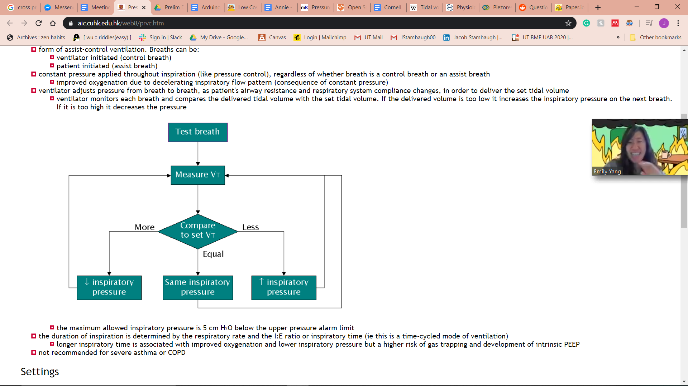

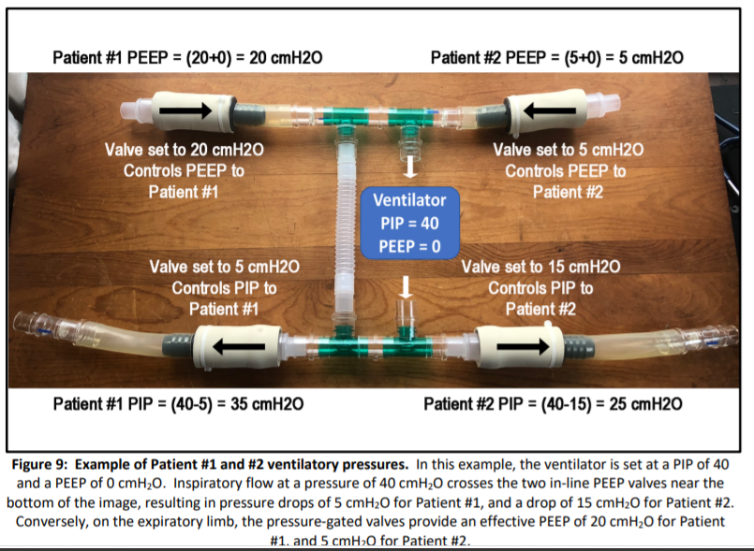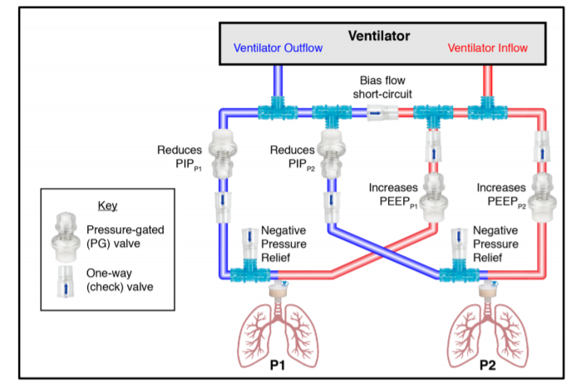

**Materials:**

**Useful Links:**

* Arduino low cost spirometer: <https://www.instructables.com/id/Low-Cost-Spirometer/>
* UW Low costs spirometer: <https://pdfs.semanticscholar.org/d6dd/0937dc88e5ef904cb2beb6551317c5551486.pdf>
* Why is tidal volume important: <https://www.ncbi.nlm.nih.gov/books/NBK546706/>
* How does pressure-controlled ventilation work: <https://www.aic.cuhk.edu.hk/web8/prvc.htm>
* Piezoresistive: <https://www.hindawi.com/journals/js/2019/2431731/>
* Ventilator splitting background: <https://emcrit.org/pulmcrit/split-ventilators/>
* Solenoid Pressure Valve: <https://www.instructables.com/id/Pressure-Control-Using-Arduino/>

<https://www.bc-robotics.com/tutorials/controlling-a-solenoid-valve-with-arduino/>

<https://www.instructables.com/id/Controling-a-solenoid-valve-with-an-Arduino/>

* [Where to put a spirometer?](https://www.gehealthcare.com/white-paper/comparison-of-patient-spirometry-and-ventilator-spirometry)
  + 